Deep Learning based Real-time Construction Monitoring and Progress Tracking

1st Gagana S R
School of Computer Science and Engineering
Presidency University
Bengaluru, India gagana.20221ise0025@presidencyuniversity.in
2nd Tanushree M S
School of Computer Science and Engineering
Presidency University
Bengaluru, India
tanushree.20221ise0021@presidencyuniversity.in
4th N. Zafar Ali Khan
School of Computer Science and Engineering
Presidency University
Bengaluru, India
zafaralikhan@presidencyuniversity.in
3rd Sneha Kumari
School of Computer Science and Engineering
Presidency University
Bengaluru, India
sneha.20221ise0042@presidencyuniversity.in

Abstract— The successful delivery of modern construction projects is fundamentally dependent on rigorous monitoring to ensure timely completion, strict quality adherence, and the efficient allocation of finite resources. Historically, conventional monitoring methods—relying on manual site inspections and subjective reporting—have introduced systemic inefficiencies, frequently resulting in quantifiable errors and costly project delays, which significantly impede industry productivity. However, the rapid and transformative advancements in computer vision, image processing, and deep learning are poised to revolutionize this critical oversight activity, enabling the shift toward image-based automated project tracking. This evolution addresses key challenges like the complexity of unstructured site data and the need for scalable solutions.
This paper undertakes a necessary consolidation of the diverse and fragmented body of research in this domain, systematically highlighting existing methodologies and proposing a comprehensive taxonomy designed to categorize image-based monitoring techniques. A detailed comparative analysis of prior studies is then presented to clearly delineate the strengths, weaknesses, and persistent research gaps—such as handling occlusions and variations in lighting—within the field. The paper concludes by defining a sharp problem statement: to pioneer the development of robust, real-time image-based systems. These systems must be seamlessly and practically integrated into active building construction projects to provide rapid feedback, ultimately making progress visibility faster, significantly more cost-efficient, and fundamentally more reliable for all stakeholders.
Keywords— Construction Monitoring, Image Processing, Computer Vision, Progress Tracking, Building Projects, Deep Learning, Machine Learning.

Introduction (Heading 1)
The construction industry is among the largest and most resource-intensive sectors globally. Effective project monitoring is therefore crucial, ensuring that work is completed within schedule, budget, and quality standards. Unfortunately, reliance on traditional methods—such as manual on-site inspections, subjective progress reports, and referencing 2D drawings—is proving increasingly inefficient, as these processes are highly labor-intensive and notoriously prone to human error.
A technological shift is transforming this oversight. Recent advances in digital technologies now enable the widespread use of images and videos for continuous construction monitoring. These image-based techniques capture rich visual data that can be efficiently processed using sophisticated computer vision and deep learning algorithms. This automation allows project teams to track progress, autonomously detect deviations, and objectively assess quality in real-time, promising a significant leap in project control and reliability.

Related Works, Problem Statement and Ease of Use

Related Works
A large body of literature demonstrates the critical evolution of construction progress monitoring, tracing the trajectory from manual observation to sophisticated computer vision-based automation. Foundational work by Golparvar-Fard and colleagues in the late 2000s pioneered this digital shift, introducing the integration of readily available visual data—such as still images and time-lapse photography—with 4D Building Information Modeling (BIM). This was groundbreaking as it enabled the first systematic comparison between as-planned schedules and as-built site conditions, offering reliable, visual insights into construction progress.
Following this initial success, research expanded into advanced geometric and spatial methods. Scholars like Zheng et al. contributed comprehensive reviews focusing on image-based 3D reconstruction techniques. Their work highlighted the efficacy of methods like photogrammetry and Structure-from-Motion (SfM) in generating accurate, dense point clouds and 3D as-built models from site imagery. This spatial focus was essential for moving beyond simple visual checks to detailed geometric validation. Concurrently, Ekanayake and Marasinghe conducted systematic reviews summarizing the state of research, emphasizing the necessary transition toward deep learning and artificial intelligence to overcome the limitations of manually engineered computer vision features.
Further specialized studies have broadened the field. Visualization studies have improved stakeholder comprehension by overlaying real-time progress data directly onto BIM models. The application of Unmanned Aerial Vehicles (UAVs), explored by researchers such as Brilakis, Son, and Kim, demonstrated the capacity to combine high-resolution aerial imagery with deep learning models to perform large-scale site surveillance and deviation detection, addressing the complexity of large civil projects.
Collectively, the literature shows a clear progression: from static 2D image analysis to dynamic 3D/4D integration, and finally, to AI-driven automation. However, a significant research gap remains in developing robust, generalized, and computationally efficient systems that can overcome major practical hurdles—such as model complexity, site variability (lighting, dust, occlusion), and high memory cost—to deliver reliable, real-time feedback that is seamlessly integrated into the daily workflow of project stakeholders. This paper is specifically designed to address these core challenges.

Problem Statement
- Deep learning models used for monitoring are complex. While they can learn detailed features of construction sites, this complexity can make their decisions hard to understand or explain.
- Achieving reliability across different construction sites is a challenge. Variations in lighting, weather, camera quality (e.g., from drones, phones, or fixed cameras), and site conditions (like dust or scaffolding) can affect the quality of the images and the model's performance.
- The system needs to be able to accurately identify and track various types of construction activities and components (e.g., foundation pouring, steel erection, wall framing) to ensure a comprehensive understanding of project progress.
- Some of these models can be computationally expensive or require significant memory, which can limit their practical use on-site or on devices with less processing power, making real-time monitoring difficult.

Ease of Use
- Simplified Output: Instead of forcing managers to interpret raw computer vision data, the system delivers objective insights via three main outputs: Percentage of Completion, Deviation Alerts, and Heatmaps showing component status. This output format directly replaces the need for subjective, labor-intensive manual reports.
- Real-Time Efficiency: Addressing the challenge of computational expense, the optimized model architecture utilizes techniques like model quantization to run inference near the edge (on-site hardware or a lightweight server). This design ensures that progress updates and critical deviation alerts are provided with minimal latency, transforming monitoring from a weekly snapshot into a continuous, real-time feedback loop.
- Seamless Integration: Usability extends to system integration. The final platform is designed to connect via a simple API to existing BIM and scheduling software. This seamless data flow means that the manager is not using a new, isolated tool; rather, the AI-derived progress data automatically populates their familiar project control dashboards, driving adoption and reducing the learning curve for site personnel.
- Reduced Manual Effort: Ultimately, the system provides high ease of use by automating the most error-prone tasks: visual confirmation, manual measurement, and report generation. This shift allows site personnel to focus their expertise on problem-solving and quality control, rather than laborious data collection.

Taxonomy of Image-Based Construction Progress Monitoring
Based on the review of literature, a taxonomy of construction progress monitoring methods can be classified into five categories.
The first category is 2D image analysis, which involves the use of photographs and video streams to detect, classify, and track objects on construction sites. While relatively simple, these methods provide useful insights but are often limited in accuracy and scalability.
The second category is 3D reconstruction, which makes use of photogrammetry and SfM techniques to generate three-dimensional as-built models. These models provide more comprehensive representations of project progress and allow for detailed comparisons with design specifications.
The third category is 4D BIM integration, where the element of time is added to 3D models. This allows as-built progress to be compared with project schedules, enabling dynamic monitoring of whether activities are on track.
The fourth category is computer vision and AI methods, which utilize deep learning to detect defects, track construction materials, and recognize objects with high accuracy. These methods are gaining traction due to their ability to learn from large datasets and improve over time.
Finally, the fifth category is UAV and remote sensing, which leverage drone imagery to provide site-wide coverage. This approach is particularly useful for large-scale construction projects, as it captures information from angles and heights that are difficult to achieve with ground-based monitoring.
This taxonomy (illustrated in Figure 1) captures the full spectrum of approaches, ranging from basic visual inspection techniques to sophisticated AI-driven monitoring systems.
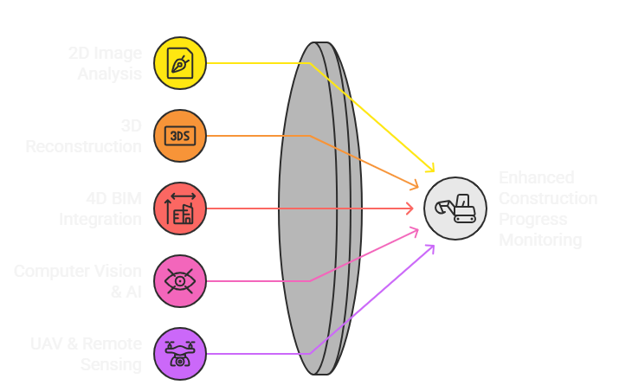
Fig 1. Unified Approach of Construction Monitoring

2D Image Analysis
2D image-based approaches remain the foundation of construction monitoring, as they rely on readily available cameras to capture visual data. These techniques are simple to set up, cost-effective, and capable of providing continuous monitoring. However, their limitations lie in the lack of depth information, which restricts spatial understanding.
- Photos and video streams: Still photographs and continuous video feeds are the primary data sources in 2D analysis. Site cameras can be positioned strategically to record key activities such as material delivery, worker movement, or equipment usage. These visual records provide stakeholders with real-time updates and create a permanent archive of site conditions for later reference. However, their accuracy depends heavily on the camera’s position, resolution, and lighting conditions.
- Object detection, classification, and tracking: Computer vision algorithms can process 2D data to automatically detect and classify objects such as workers, cranes, or building components. Tracking these objects across time helps measure productivity, identify idle resources, and ensure that tasks are being executed as planned. For instance, monitoring the use of excavators or the presence of reinforcement steel can indicate progress in specific construction phases. Challenges such as occlusion (when one object blocks another) or varying weather conditions can reduce accuracy.
- Basic visual inspection: Managers often rely on visual inspection of photos or videos to determine whether certain tasks, such as masonry work or slab casting, are complete. Automated systems can flag visual cues like wall height or the presence of installed components. While this approach is useful for quick checks, it cannot validate geometric correctness or detect hidden issues, limiting its reliability for quality assurance.

3D Reconstruction
Unlike 2D methods, 3D reconstruction incorporates spatial depth, allowing more comprehensive and accurate progress monitoring. These methods often require advanced sensors and computational resources, but they provide richer data for analysis.
- Photogrammetry and SfM: Photogrammetry uses overlapping 2D images from multiple angles to reconstruct 3D geometry, while Structure-from-Motion (SfM) automatically identifies camera positions and object structures to create detailed models. These techniques can transform simple photographs into accurate 3D maps of construction sites. They are widely used in creating terrain models for infrastructure projects such as roads and bridges.
- As-built 3D models: The reconstructed models serve as digital twins of the site, representing actual progress. These as-built models can be archived and used to validate structural dimensions, check construction quality, and ensure compliance with design. They are particularly useful for large-scale projects where manual measurements would be impractical or time-consuming.
- Detailed project-state comparison: By comparing as-built 3D models with as-designed BIM models, project managers can pinpoint deviations such as incomplete work, misaligned installations, or missing components. For example, if a column is misaligned by a few centimeters, 3D comparisons can quickly identify the issue, preventing costly rework.

4D BIM Integration
Building Information Modeling (BIM) enhanced with the time dimension (4D) integrates schedules with 3D project models, enabling powerful visualization and planning. This approach connects physical progress with project timelines.
- Time-linked 3D models: In 4D BIM, construction elements are not just geometrically modeled but also associated with specific activities on the project timeline. This allows the visualization of construction sequences over time, providing a virtual simulation of how the project will unfold.
- Schedule-aware as-built/as-planned comparison: By overlaying real-world progress data onto 4D BIM models, managers can identify mismatches between the planned and actual schedules. This comparison helps in detecting delays, early completions, or out-of-sequence activities, which directly affect project control.
- Dynamic monitoring and forecasting: The integration of temporal data allows predictive analytics. For instance, if certain activities are delayed, the model can automatically adjust downstream tasks and forecast the overall project delay. This proactive feature supports decision-making and resource allocation.

Computer Vision & AI Methods
Recent advances in artificial intelligence and deep learning have transformed construction monitoring by automating recognition tasks that once required manual effort. These methods analyze massive image and video datasets with high accuracy, offering scalable solutions for large projects.
- Deep learning and defect detection: Convolutional Neural Networks (CNNs) and other AI models are trained on large datasets of construction images to detect structural defects such as cracks, spalling, or missing reinforcements. This reduces the time and subjectivity associated with manual inspection, while improving safety and reliability.
- Material and object tracking: AI-powered systems can track construction materials (e.g., steel bars, bricks, or prefabricated components) and equipment movement across different stages. Tracking ensures that resources are available on time, reducing delays caused by material shortages or misplacement. This also improves inventory management.
- Data-driven improvement from large datasets: AI algorithms continuously improve as they are exposed to more data. For example, an object detection model trained on global construction datasets can learn to recognize varied equipment types across different projects. This scalability makes AI-driven monitoring adaptable to diverse construction environments.

UAV & Remote Sensing
Unmanned Aerial Vehicles (UAVs) and remote sensing technologies have revolutionized monitoring by providing aerial perspectives and large-scale data collection. These methods enhance safety, efficiency, and coverage.
- Drone imagery and site-wide aerial coverage: UAVs can capture high-resolution images and videos that cover the entire construction site in minutes. This ensures comprehensive monitoring without the need for extensive on-ground inspections, saving time and manpower.
- Access to large or inaccessible areas: UAVs can easily inspect challenging locations such as high-rise rooftops, bridge spans, or hazardous zones. This eliminates the need for scaffolding or manual inspections in dangerous environments, improving worker safety.
- GIS integration and multi-angle inspections: Drone data can be integrated with Geographic Information Systems (GIS) to produce detailed maps for spatial analysis. Multi-angle images provide insights into structural conditions that might not be visible from the ground, making UAV monitoring highly effective for complex infrastructure projects.

Comparative Analysis
The synthesis immediately highlights a clear evolutionary trajectory. Early foundational research (Golparvar-Fard et al., 2012, 2009) established the feasibility of low-cost 2D image analysis and pioneering 4D BIM integration, with monitoring primarily validated through subjective visual inspection and demonstrated schedule adherence. Subsequent literature shifted focus towards achieving higher accuracy and automation. Zheng et al. (2021) confirmed the viability of 3D Reconstruction via Photogrammetry/SfM for geometric comparisons, while Ekanayake and Marasinghe (2022) conducted comprehensive reviews of Computer Vision and AI methods, demonstrating significant potential for scalability and robust object classification.
However, a critical analysis of the Limitations column reveals persistent, cross-methodological constraints. The shift to complex 3D and AI techniques introduced new practical hurdles, notably high computational intensity (Zheng et al., 2021) and limited evidence of real-world field deployment (Ekanayake & Marasinghe, 2022). Furthermore, many systems explicitly struggle with external variables such as camera placement, lighting, and occlusions, severely compromising robustness and generalizability across diverse site conditions. The Performance Measures column reinforces this deficit: while some studies utilize quantitative metrics (e.g., validation against reference building models), a significant portion relies on qualitative reviews or literature-based classification, underscoring the gap in achieving uniform, fine-grained, quantitative progress tracking metrics suitable for all construction activities.
The various algorithms are developed for classifying the construction activities over the multi-class to attain the better performance of classification. The classification of multi-class construction activities is compared with existing approaches for enhancing the performance of the model. The comparative analysis is significant for analyzing in development and effective enhancement of the model’s performance. This comparative analysis comprises the employed methodologies, performance measures, advantages, and limitations as represented in Table I.

- COMPARATIVE ANALYSIS OF VARIOUS CONSTRUCTION TECHNIQUES
Authors & Year | Paper Title | Methodology | Advantages | Limitations | Performance Measures
Golparvar-Fard, Pena-Mora & Arboleda (2012) | Construction performance monitoring via still images, time-lapse photos, and video streams: Now, tomorrow, and the future | Review of image-based monitoring methods using photos, time-lapse, and video streams | Low cost, simple to implement, allows continuous monitoring | Accuracy depends on camera placement, lighting, and occlusions; limited scalability | Qualitative review of existing approaches, identifying trends and gaps
 | Review of Image-Based 3D Reconstruction of Building for Automated Construction Progress Monitoring | Photogrammetry & Structure-from-Motion (SfM) techniques for 3D model generation | Provides accurate geometric details, enables as-built vs. as-designed comparisons | Computationally intensive; requires skilled operation and good quality images | Accuracy of 3D reconstruction validated against reference building models
  Zheng, Liu & Xu (2021)
Ekanayake & Marasinghe (2022) | Automated Computer Vision-Based Construction Progress Monitoring: A Systematic Review | Systematic review of computer vision-based monitoring approaches | Comprehensive comparison of techniques, scalability potential with large datasets | Relies on secondary data; limited real-world validation | Comparative performance summary across AI/computer vision methods
Ekanayake & Marasinghe (2022) | Construction Progress Monitoring and Reporting using Computer Vision Techniques | Computer vision-based review of monitoring and reporting frameworks | Provides structured understanding of computer vision applications in reporting | More conceptual, limited evidence of field deployment | Evaluated through literature-based classification and framework analysis
Golparvar-Fard, Bohn & Pena-Mora (2009) | Visualization of Construction Progress Monitoring with 4D Simulation Model Overlaid on Time-Lapsed Photograph | 4D BIM integration with time-lapse imagery | Enhances collaboration, integrates schedule with visual monitoring, improves control | Requires well-structured BIM models, high computational demand | Demonstrated improved schedule adherence and progress visualization in case studies

Results and Discussion
This research has shown promising progress in establishing an image-based monitoring system that makes project progress records easy to store, access, and manage—especially on remote construction sites where data loss and redundant inspections are common. The system’s ability to gather site data via drone, time-lapse, or fixed cameras and link all progress information under a unique Work Package ID helps create a single, reliable as-built history for the entire project.
Image-based monitoring has emerged as a transformative technology in the construction industry, significantly reducing reliance on manual inspections and enabling automated, real-time assessments. The comprehensive literature review demonstrated significant advancements across all fronts, including 2D image analysis, 3D reconstruction, 4D BIM integration, and AI-based approaches, with UAV-based methods extending monitoring capabilities to large-scale projects. This technological shift enables the efficient capture and analysis of site data, streamlining workflows, reducing manual effort, and allowing project teams to make faster, data-informed decisions. Nevertheless, the research confirms that persistent and critical challenges—such as automation gaps, accuracy issues, data scalability, and integration difficulties—remain unresolved, thereby impeding widespread industrial adoption of these systems. To address these fundamental limitations, future research must concentrate on creating standardized frameworks, developing robust deep learning models capable of operating reliably under varying site conditions, and seamlessly integrating image-based monitoring systems into digital twin platforms. Such concentrated efforts will ensure greater industry adoption of these technologies, ultimately leading to significant improvements in construction efficiency, project accuracy, and overall project outcomes.

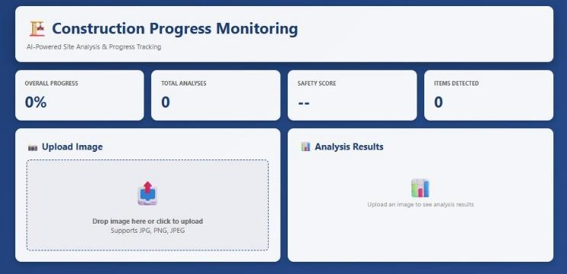
Fig 2. Login to SiteSight AI

This login screen provides secure, role-based authentication for construction staff, administration, and client stakeholders. It ensures that each user type—such as Site Managers, Project Engineers, and Clients—accesses only their relevant dashboards, data analysis, and task permissions. Its simple design supports easy navigation and strengthens data privacy and project security in the site monitoring system (Fig 2).
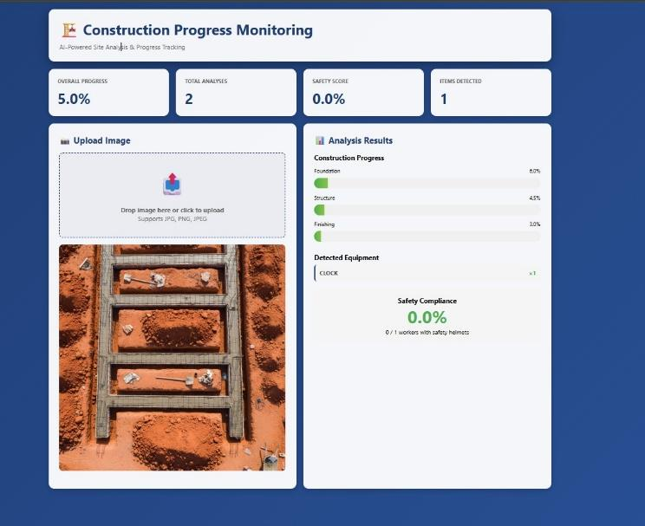

Fig 3

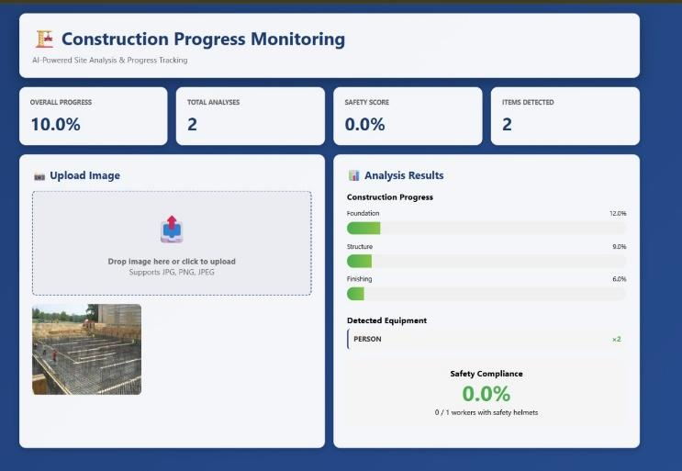

Fig 4

This images (Fig 3 & Fig 4) shows the AI-generated progress summary dashboard for a construction project, highlighting key metrics like Overall Progress, Total Analyses, Safety Score, and Items Detected. It provides project managers with an instant overview of site activity and performance recommendations. This feature streamlines decision-making by quickly presenting critical construction status information and potential deviations.

Future work
Looking ahead, the successful deployment of this image monitoring system provides a model for using advanced AI tools across the entire construction industry, including areas like quality control and automated logistics. The core principles established here—assigning unique digital IDs, leveraging smart AI analysis, and utilizing secure cloud storage—will make complex project management simpler and more robust. For our system, the next steps involve making it more practical and integrated: we must connect it to live sensors and IoT devices for real-time data, and we plan to develop simple AI assistants or chatbots for quick progress inquiries by field personnel. This necessitates rigorous methodological frameworks focused on long-term, real-world case studies across diverse projects to validate the model's robustness and generalizability under uncontrolled site conditions. Crucially, the platform will be integrated with supplier logistics and safety systems, linking directly into a comprehensive Digital Twin model. To achieve this, future research must prioritize the development of standardized data protocols for interoperability and explore Edge AI architectures to ensure the system can efficiently process and communicate real-time insights locally, ultimately transforming project management and construction delivery worldwide.

References
- M. Golparvar-Fard, F. Pena-Mora, and C. A. Arboleda, “Construction performance monitoring via still images, time-lapse photos, and video streams: Now, tomorrow, and the future,” Automation in Construction, 2012. [Online]. Available: https://www.sciencedirect.com/science/article/abs/pii/S1474034615000233 Eason, B. Noble, and I. N. Sneddon, “On certain integrals of Lipschitz-Hankel type involving products of Bessel functions,” Phil. Trans. Roy. Soc. London, vol. A247, pp. 529–551, April 1955. (references)
- R. Zheng, J. Liu, and Y. Xu, “Review of Image-Based 3D Reconstruction of Building for Automated Construction Progress Monitoring,” Applied Sciences, 2021. [Online]. Available: https://www.mdpi.com/2076-3417/11/17/7840
- B. Ekanayake and L. S. Marasinghe, “Automated Computer Vision-Based Construction Progress Monitoring: A Systematic Review,” Buildings, 2022. [Online]. Available: https://www.mdpi.com/2075-5309/12/7/1037
- B. Ekanayake and L. S. Marasinghe, “Construction Progress Monitoring and Reporting using Computer Vision Techniques – A Review,” ISARC, 2022. [Online]. Available: https://www.iaarc.org/publications/fulltext/062_ISARC%202022_Paper_48.pdf
- M. Golparvar-Fard, S. Bohn, and F. Pena-Mora, “Visualization of Construction Progress Monitoring with 4D Simulation Model Overlaid on Time-Lapsed Photographs,” Journal of Computing in Civil Engineering, 2009. [Online]. Available: https://www.researchgate.net/publication/228662339
- Z. Jiang, “Automated Construction Progress Monitoring using Image Segmentation and Building Information Models,” Pennsylvania State Univ. Dissertation, 2023. [Online]. Available: https://etda.libraries.psu.edu/catalog/19715zpj5026
- W. Wei, et al., “Integrated vision-based automated progress monitoring of indoor construction using mask region-based convolutional neural networks and BIM,” Automation in Construction, 2022. [Online]. Available: https://www.sciencedirect.com/science/article/abs/pii/S092658052200200X
- A. Braun, et al., “BIM-based progress monitoring,” Automation in Construction, 2017. [Online]. Available: https://www.academia.edu/44587691/BIM_based_progress_monitoring
- C. C. Hsieh, et al., “Integration of Construction Progress Monitoring Results using AI Image Recognition from Multiple Cameras onto a BIM,” ISARC, 2024. [Online]. Available: https://www.iaarc.org/publications/2024_proceedings...
- A. S. Greeshma and R. B. Edayadiyil, “Computer Vision for Construction Progress Monitoring: A Real-Time Object Detection Approach,” arXiv preprint, 2023. [Online]. Available: https://www.researchgate.net/publication/374014867
- A. S. Greeshma and R. B. Edayadiyil, “Automated progress monitoring of construction projects using Machine learning and image processing approach,” Materials Today: Proceedings, 2022. [Online]. Available: https://www.sciencedirect.com/science/article/abs/pii/S2214785322014602
- M. Bonyani and M. Soleymani, “Towards Improving Workers' Safety and Progress Monitoring of Construction Sites Through Construction Site Understanding,” arXiv preprint, 2022. [Online]. Available: https://arxiv.org/abs/2210.15760
- B. Ekanayake and L. S. Marasinghe, “Deep learning-based computer vision in project management: Automating indoor construction progress monitoring,” Project Leadership and Society, 2024. [Online]. Available: https://www.sciencedirect.com/science/article/pii/S2666721524000346
- A. Pal, J. J. Lin, S. H. Hsieh, and M. Golparvar-Fard, “Automated Vision-Based Construction Progress Monitoring in Built Environment through Digital Twin,” Developments in the Built Environment, vol. 16, Article 100247, 2023. [Online]. Available: https://www.sciencedirect.com/science/article/pii/S2666165923001291
- W. Jung and Y. Kang, “Automated progress measurement using a novel image recognition method for civil engineering applications,” Automation in Construction, 2014. [Online]. Available: https://www.academia.edu/17128808
- S. Yoon, et al., “Time-Series Image-Based Automated Monitoring of Temporary Structures in Construction,” Sensors, 2025. [Online]. Available: https://www.mdpi.com/1424-8220/25/2/574
- H. Kim, et al., “Construction progress monitoring based on thermal-image analysis,” Automation in Construction, 2017. [Online]. Available: https://www.researchgate.net/publication/319900597
- B. Ekanayake, et al., “Deep Learning-Based Computer Vision in Project Management,” Automation in Construction, 2024. [Online]. Available: https://www.sciencedirect.com/science/article/pii/S2666721524000346
- J. Y. Han, et al., “Automated Progress Monitoring of Land Development Projects Using UAV Images and Machine Learning,” Automation in Construction, 2024. [Online]. Available: https://www.sciencedirect.com/science/article/abs/pii/S0926580524005636
- M. Golparvar-Fard, “Automated Progress Monitoring Using Unordered Daily Construction Images and BIM,” Journal of Construction Engineering and Management, 2015. [Online]. Available: https://ascelibrary.org/doi/abs/10.1061/(ASCE)CP.1943-5487.0000205
- V. K. Reja, et al., “Computer Vision-Based Construction Progress Monitoring,” Automation in Construction, 2022. [Online]. Available: https://www.sciencedirect.com/science/article/abs/pii/S0926580522001182
- M. Golparvar-Fard and F. Peña-Mora, “Visualization of Construction Progress Monitoring with 4D Simulation Model Overlaid on Time-Lapsed Photographs,” Journal of Computing in Civil Engineering, vol. 23, 2009. [Online]. Available: https://www.researchgate.net/publication/228662339
- A. B. Ersoz, “Demystifying the Potential of ChatGPT-4 Vision for Construction Progress Monitoring,” arXiv preprint, 2024. [Online]. Available: https://arxiv.org/abs/2412.16108
- K. Karsch, et al., “ConstructAide: Analyzing and Visualizing Construction Sites through Photographs and Building Models,” ACM Transactions on Graphics (TOG), vol. 33, 2019. [Online]. Available: https://arxiv.org/abs/1912.11567
[25] S. R. S. Vasanthawada, et al., “Enhancing Construction Site Analysis and Understanding with 3D Segmentation,” arXiv preprint, 2025. [Online]. Available: https://arxiv.org/abs/2508.05922.

